Range Check

Definition
# Source: AI Source: Provided by: [Data Path: Persons Table -> ID Column: 1, Name_En Column: Motasem Essam] -> From: [Chatgpt (GPT‑5 Mini)] on [12/10/2025]
Range Check ensures that the data entered falls within a predefined minimum and maximum value.
- It prevents invalid numeric entries that are too high, too low, or unrealistic.
- Commonly applied to numbers, dates, percentages, or scores.

Key idea:
# Source: AI Source: Provided by: [Data Path: Persons Table -> ID Column: 1, Name_En Column: Motasem Essam] -> From: [Chatgpt (GPT‑5 Mini)] on [12/10/2025]
It’s like checking that a student’s test score is between 0 and 100 before accepting it.

Characteristics
# Source: AI Source: Provided by: [Data Path: Persons Table -> ID Column: 1, Name_En Column: Motasem Essam] -> From: [Chatgpt (GPT‑5 Mini)] on [12/10/2025]
- Validates the value itself, not just the format.
- Often applied to numerical fields, ages, quantities, or grades.
- Can be automated using software rules, database constraints, or input forms.
- Helps prevent illogical or impossible data from entering the system.

Examples
# Source: AI Source: Provided by: [Data Path: Persons Table -> ID Column: 1, Name_En Column: Motasem Essam] -> From: [Chatgpt (GPT‑5 Mini)] on [12/10/2025]
- Student Test Scores
- Expected range: 0–100
- Valid: 85 ✅
- Invalid: 120 ❌
- Age Validation
- Expected range: 5–100 years
- Valid: 25 ✅
- Invalid: 150 ❌
- Temperature Recording
- Expected range: -50°C to 50°C
- Valid: 23°C ✅
- Invalid: 75°C ❌
- Quantity in Inventory
- Expected range: 1–500 units
- Valid: 50 ✅
- Invalid: 600 ❌

Advantages
# Source: AI Source: Provided by: [Data Path: Persons Table -> ID Column: 1, Name_En Column: Motasem Essam] -> From: [Chatgpt (GPT‑5 Mini)] on [12/10/2025]
- Ensures values are realistic and within acceptable limits
- Reduces data entry errors
- Maintains data integrity for calculations and reports
- Useful for numeric analysis, reporting, and decision-making

Disadvantages
# Source: AI Source: Provided by: [Data Path: Persons Table -> ID Column: 1, Name_En Column: Motasem Essam] -> From: [Chatgpt (GPT‑5 Mini)] on [12/10/2025]
- Cannot detect incorrect data within the range (e.g., wrong student score entered as 85 instead of 58)
- Needs accurate definition of min/max limits
- May reject unusual but valid values if limits are too strict

Example Section
# Source: AI Source: Provided by: [Data Path: Persons Table -> ID Column: 1, Name_En Column: Motasem Essam] -> From: [Chatgpt (GPT‑5 Mini)] on [12/10/2025]
A school database records student ages:
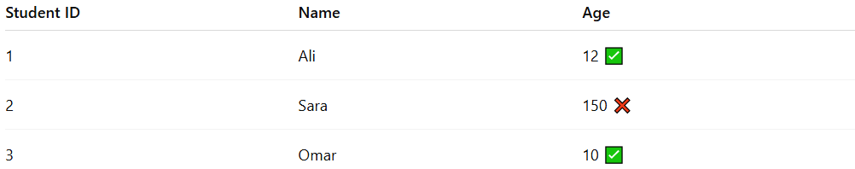
Student ID | Name | Age
1 | Ali | 12 ✅
2 | Sara | 150 ❌
3 | Omar | 10 ✅
- The system rejects Sara’s age because it exceeds the valid range of 5–100.
- Only ages within the allowed range are stored for enrollment purposes.

